Artificial Intelligence – BSCS – Spring 2026 Midterm Exam
COURSE CODE: AL352
Name: _________________________ Reg.No. _______________________
Allowed Time: 1.5 hours Total Marks: 100
Note: Understanding of the questions is a part of the exam. Correct answer without step work will not be graded. Attempt ALL questions on Answer Sheet.
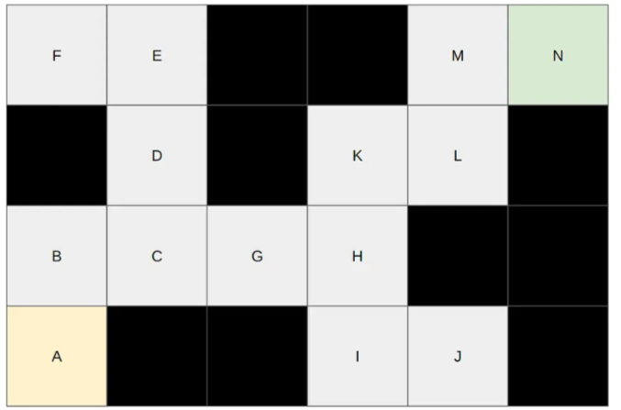
Question-1: CLO2 [20]
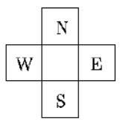
In describing the steps of the algorithm, each position will be denoted by a pair of numbers which are the horizontal and vertical coordinates such as (x,y) where x denotes the horizontal coordinate and y denotes the vertical coordinate. In the given figure, the start state is A (1,1) and the goal state is N (6,4). The Manhattan distance between the points (x1, y1) and (x2, y2) is given by d = (|x2-x1|+|y2-y1|) . Solid states are not reachable.
Design the solution using Hill Climbing algorithm if the agent can reach at the Goal State (Note: In case of tie, E action has highest priority). Also write down the correct sequence of actions from A to the terminal state N.

Question-2: CLO2 [10+10]
Consider the following search space, where S is the initial state and G is the goal state. If you find any tie follow alphabetical order. Each edge represents the cost that takes you from one state to the next state. Design solution for following parts ;Give the sequence of the states the following strategies will visit and also mention final solution path for each
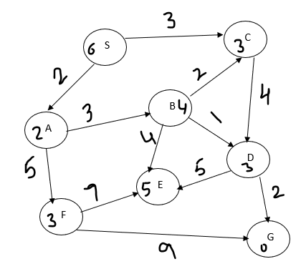
- Best First search
- Uniform Cost Search

Question-3: For Question-2 both parts; critically analyse either they are providing optimal solution or not. CLO 3 [10]

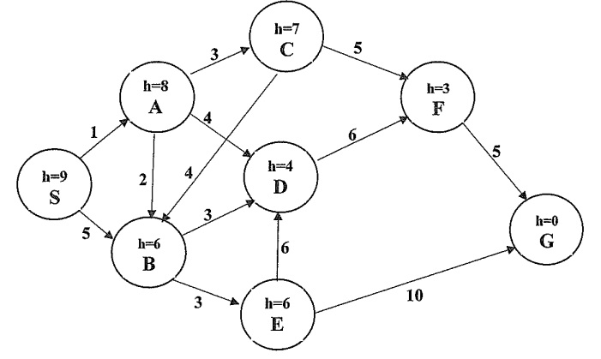
Question-4: CLO2 [15+5]
The start node is S, and the goal node is G. The heuristic value h(n) of each node is given inside nodes.

- Design solution using IDA* algorithm on provided graph.
- Is heuristic admissible? Give reasons to support your choice.

Question-5: CLO2 [10+05=15]
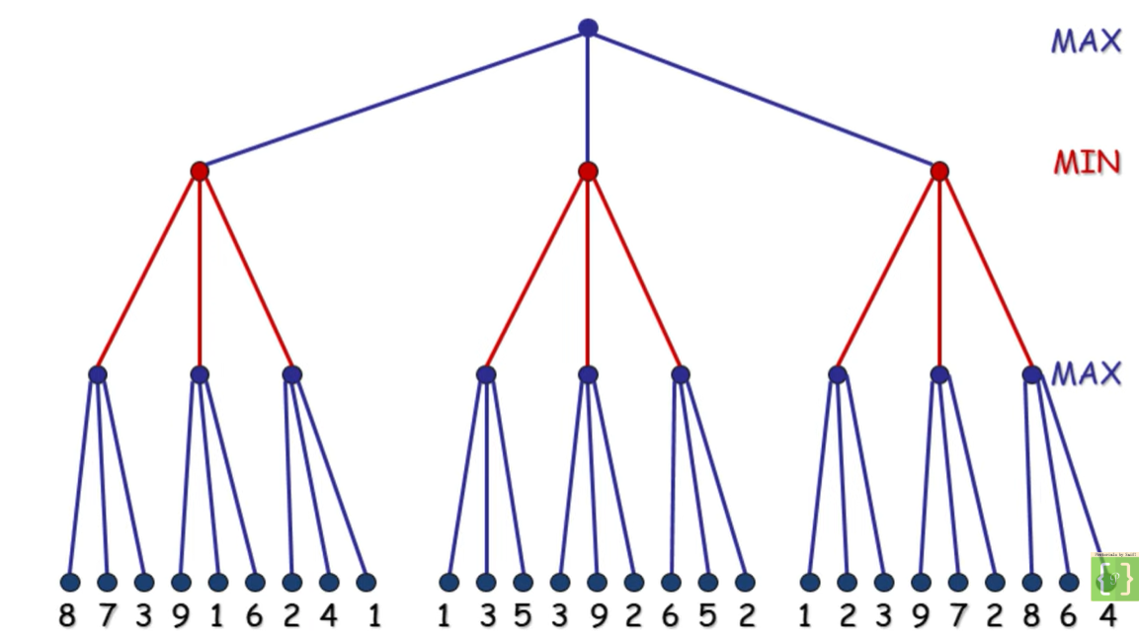
- Design solution using the Minimax algorithm and determine the best move for the MIN player at the root.

Question-5: CLO1 (Attempt this question only on Answer sheet)
Fill the following table for the given agents using your understanding of agents [(5*2)+5=15]
Agent | Architecture | Deterministic/ Stochastic
Google Map | Utility-based agent | Stochastic
Non-interactive Tutor | Simple reflex agent | Deterministic
Image-based age detector (trained and improves with more data) | Learning agent | Stochastic
Automatic hand dryer that turns ON when hands are detected | Simple reflex agent | Deterministic
Spam email filter that improves over time using data | Learning agent | Stochastic

[Good Luck]

